Developing an Effective Workforce for Emerging Technologies in Industrial Biotechnology
Presented by: 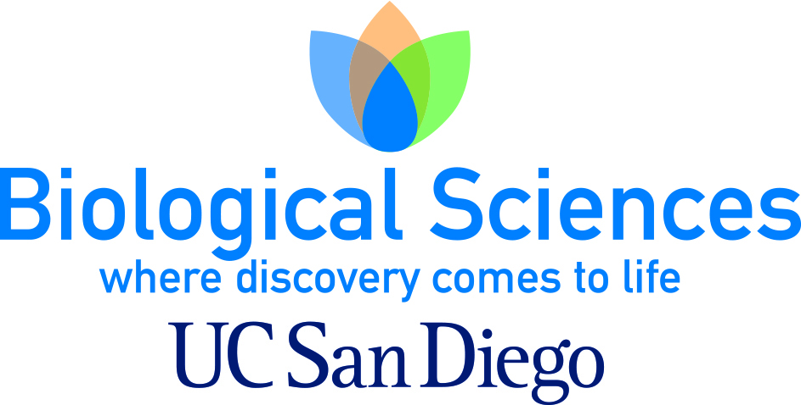
Moderator: Jason Anderson, Vice President, CleanTECH San Diego
Panelists:
Jeff Lievense, Executive VP, Process Technology, Genomatica
Mike Fino, Professor, Bioprocess Technology, MiraCosta College and UCSD California Center for Algae Biotechnology
Robert Pomeroy, Faculty, Department of Chemistry and Biochemistry, UCSD
Shannon McDonald, Business Development & Marketing Manager, UC San Diego Extension
UC San Diego is a leader in basic and translational research within the industrial biotechnology and biofuels fields. A panel of academic and industry experts will explore the field from business and technical perspectives. Special attention will be given to workforce development, including new approaches to prepare a capable team.
Blue + White = Green?
Exploring Marine Biodiversity and Bringing Sustainable Solutions to Industry
Presented by: 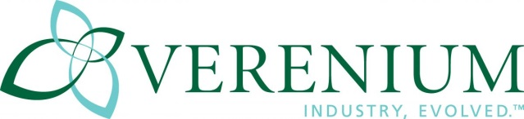
Moderator: Kenneth Barrett, Vice President, Business Development, Verenium Corporation
Panelists:
Jody W. Deming, Professor, University of Washington, School of Oceanography
Douglas Bartlett, Professor, Scripps Institution of Oceanography, University of California San Diego
David P. Weiner, Vice President, R&D Strategy & Partnerships, Verenium Corporation
Neil Parry, R&D Director, Biotechnology Science Leader, Unilever R&D
Jan Buch Andersen, Managing Director, Barentzymes
Biotechnology has already led to improvements in efficiencies and environmental sustainability across many industries and is driving the change from a chemical to a bio-based economy. With increasing population growth and global urbanization, this trend is expected to continue, creating an increasing need for more efficient industrial processes.
More than three and a half billion years of natural evolution has led to a tremendous diversity of microbial life that exists on our planet. This vast biodiversity represents one of the world’s most valuable resources for the development of solutions to mankind’s biggest challenges and yet it is largely unexplored. With an emphasis on marine environments, this session will highlight recent fundamental and applied approaches to understanding and manipulating genomes from untapped microbial diversity. Furthermore, the panelists will describe work on the discovery, evolution, and commercial implementation of unique products from novel microbes that are transforming industrial processes.
Advances in Algal Synthetic Biology Technologies
Presented by: 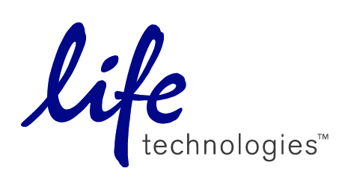
Moderator: Dr. Farzad Haerizadeh, Life Technologies
Panelists:
Dr. Farzad Haerizadeh, Life Technologies
Dr. Beth Rasala, Professor, Triton Algae Innovations
Dr. Arnaud Taton, Faculty, UCSD
Synthetic biology brings together engineers and biologists to design and build novel bio- molecular components, networks and pathways, and to use these constructs to rewire and reprogram organisms. Among industrial organisms, microalgae hold great promise as the next generation production platform for renewable fuels, chemicals, animal feed and high value products. Algae can be cultivated with high productivity on land and water not suitable for agriculture. However despite the recent heightened interest and substantial investment, the availability of standardized tools and a developed knowledge base on microalgae lag far behind many other production systems. Here in, you will hear from the industry leaders on the recent advances achieved in the last few years on synthetic biology tools and technologies for algal research and bioproduction.
U.S. Policy Outlook: 2014 – Make or Break for Advanced Biofuels and Renewable Chemicals
Presented by:
Moderator: Matt Carr, Managing Director, Industrial & Enviromental Section, Biotechnology Industry Organization
Panelists:
Ben Salisbury, Senior Policy Analys, FBR Capital Markets
Ryan Stroschein, Green Capitol LLC
Tim Urban,Washington Council Ernst & Young
The coming year marks a watershed in industrial biotech commercialization, with a new wave of cellulosic and advanced biofuels facilities coming online, and investments from across the globe to develop and produce renewable chemicals and biopolymers. But 2014 also promises unprecedented policy challenges that could threaten progress – particularly in the U.S. A panel of leading policy experts will assess the threats and opportunities on the U.S. federal policy landscape for 2014. Ben Salisbury, FBR Capital Markets, will discuss the impact of EPA’s 2014 RFS proposed rule and efforts in Congress to repeal or revise the RFS. Ryan Stroschein, Green Capitol LLC, will discuss Farm Bill negotiations and prospects for Energy Title programs. Tim Urban, Washington Council Ernst & Young, will discuss tax reform and the future of advanced biofuel and renewable chemical tax credits.

