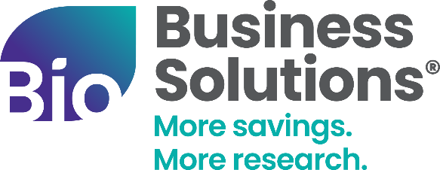


COMMUNICATIONS TOOLKIT
Launch the NFP Savings Program with the email templates, social messaging, and graphics in this toolkit.

About the BIO/NFP Partnership
Life science companies face complex and evolving risk exposures across clinical development, global operations, data, and governance. NFP works with leadership teams to help identify, structure, and manage risk aligned to business needs and growth objectives.
Through this collaboration, eligible BIO and state life science association members can access NFP’s specialized capabilities, market reach, and advisory support including preferential program pricing.
Member Benefits
Members working with NFP benefit from:
- Access to preferred pricing, which may be 10–25% below market benchmarks
- Deep life sciences risk and insurance expertise
- Advisory support designed to strengthen governance, resilience, and long-term decision-making

Website Content
[Suggested content for affiliate website]
About NFP, an Aon company
Life science companies face complex and evolving risk—across clinical development, global operations, data, and governance. NFP supports leadership teams with risk, insurance, and advisory solutions aligned to their business objectives.
Through our collaboration with BIO and NFP, [association name] members can access NFP’s specialized capabilities, market reach, and advisory support—including preferential program pricing.
Member Benefits on Risk, Insurance & Advisory Solutions
NFP serves as an advisor and advocate, helping companies make informed risk decisions aligned to their business goals.
Members working with NFP benefit from:
- Access to preferred pricing, which may be 10–25% below market benchmarks
- Deep life sciences risk and insurance expertise
- Advisory support designed to strengthen governance, resilience, and long-term decision-making
Coverage & Advisory Solutions
Property & Casualty Insurance
NFP designs coverage strategies aligned to how life science organizations operate, including:
- Product liability and clinical trial coverage
- General liability, property, auto, and workers’ compensation
- Supply chain and global transit risk
- Insurance related contract and vendor risk review
Executive, Transactional & Governance Risk
NFP supports leadership teams and boards through targeted solutions, including:
- Directors & officers (D&O), employment practices liability (EPL), fiduciary, and crime coverage
- Representations & warranties insurance and IPO readiness support
- ESG and governance advisory services
Cyber & Technology Risk
As technology and data exposure increase, NFP helps organizations prepare for and respond to cyber risk through:
- Cyber liability coverage and privacy risk consulting
- Incident response planning and readiness exercises
- Data breach preparedness and AI risk assessments
Employee Benefits & Workforce Solutions
NFP works with companies to align employee benefits and total rewards strategies with growth objectives:
- Employee health and welfare benefits including medical, dental, vision and voluntary programs
- Industry-specific benchmarking for biotech and innovation-driven organizations
- Executive benefits and key person protection strategies
- Global mobility and total rewards consulting
- HR technology integration to support benefits administration and compliance

Get Started button [link to https://www.bio.org/save/inquiry-form-nfp or where appropriate for your organization]

Announcement to Member Companies
[Suggested content for newsletter and/or other member communications]
Subject: Introducing NFP: [Association’s Name]’s New Insurance & Employee Benefits Preferred Broker
A New Member Offering
[State Association Name] is pleased to introduce an expanded member benefit designed to help life science companies manage risk, protect innovation, and support long-term growth in collaboration with NFP, an Aon company.
[Insert NFP logo, which can be downloaded from ShareVault]
About NFP
NFP, an Aon company, is a leading insurance broker and risk advisor, delivering tailored property & casualty, executive liability, cyber, and people solutions. NFP works alongside leadership teams to help identify, structure, and manage risk in a way that aligns with their business objectives.
Experience Supporting Life Sciences Companies
NFP has deep experience supporting biotech, pharmaceutical, and life sciences organizations—from early-stage development through commercialization. The team is experienced in regulatory, operational, financial, and global risks unique to this sector and designs strategies accordingly.
Key Benefits for Members
- Access to preferred pricing, typically 10–25% below market benchmarks
- Specialized life sciences insurance and advisory expertise
- Strategic support across clinical trials, governance, cyber risk, employee benefits, and growth milestones
[Call to action button] Learn how NFP can Support Your Organization [link to https://www.bio.org/save/inquiry-form-nfp or where appropriate for your organization]

Social Media Announcement
Growing life science companies face increasing complexity across risk, operations, data and governance.
[Association name] has partnered with NFP to expand access to specialized risk management and advisory support at preferred program pricing.
This partnership helps life science companies navigate operational and regulatory complexity while staying focused on research, development and commercialization.
Learn more about the NFP partnership and available benefits here: [https://www.bio.org/save/nfp]

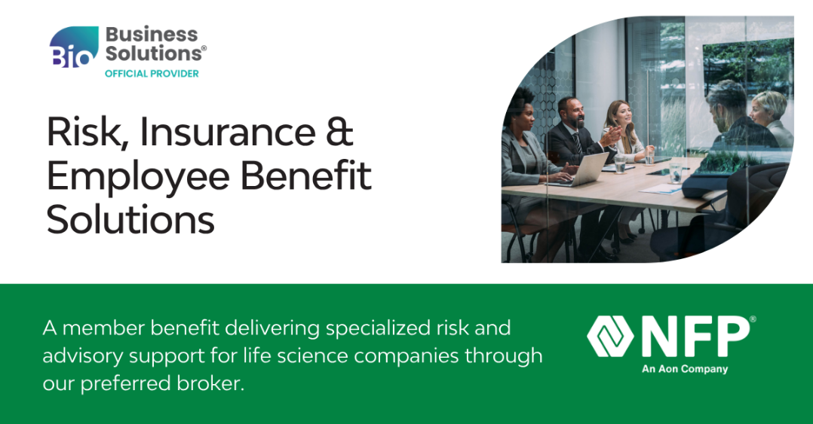
Download the graphic from ShareVault

Contact Information
Business Development Inquires: save@bio.org, BIO Business Development rep, and Scott Foster, scott.foster@nfp.com
NFP, an Aon company: Scott Foster, Managing Director, scott.foster@nfp.com

